Programming

1)With depth=6,
accuracy=0.8

2)

1 | 0.844
2 | 0.8435
3 | 0.849
4 | 0.8515
5 | 0.845
6 | 0.855
7 | 0.856
8 | 0.8575
9 | 0.86
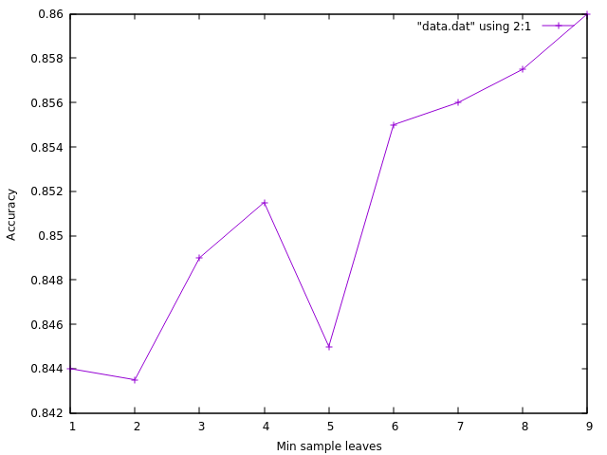

3) Accuracy=0.844

